1. In a binary PAM system, the prior probability of transmission of $S_{1}= \sqrt{E_{b}}$ is $\frac{5}{6}$ and $S_{2}= -\sqrt{E_{b}}$ is $\frac{1}{6}$. Then, the decision boundary at the receiver lies at
$γ=\frac{-1.609N_{0}}{4\sqrt{E_{b}}}$

$γ=\frac{1.609N_{0}}{2\sqrt{E_{b}}}$

$γ=\frac{-2.303N_{0}}{4\sqrt{E_{b}}}$

$γ=\frac{2.303N_{0}}{4\sqrt{E_{b}}}$

3. In two-dimensional constellation , as the number of symbols (***M***) increases, the probability of symbol error,
4. Remains same.
5. Decreases.
6. Increases always.
7. Increases only for fixed SNR per bit.
8. For 4-ary PAM with SNR per bit $\left(\frac{E_{b}}{N_{0}}=10dB\right)$, the probability of symbol error is upper bounded by (use chernoff bound)
9. 0.169
10. 0.027
11. 0.052
12. 0.0436
13. In an M- ary PAM, suppose k-bits are used. Now, if the numbers of bits is increased to 2K,then the factor by which probability of symbol error will increase (assuming $γ_{b}$ is same ) is,
$\frac{{3kγ}_{b}}{2^{k}-1}$

$\frac{2^{k}-1}{2^{k}}exp⁡\left[\frac{3kγ_{b}}{4^{k}-1}\right]$

$\frac{2^{k}+1}{2^{k}}exp⁡\left[\frac{3kγ_{b}}{4^{k}+1}\right]$

$\frac{3kγ_{b}}{2^{k}+1}$

15. Given below, two 4-ary QAM constellation

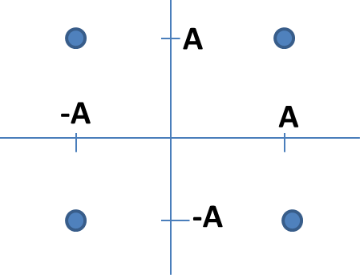 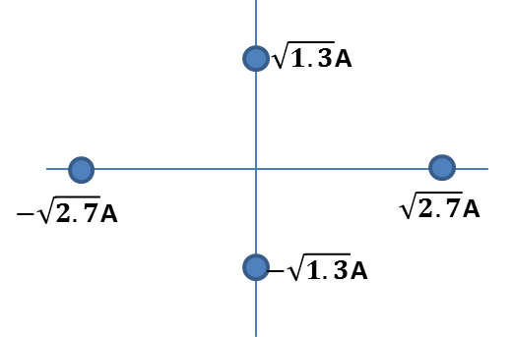

Which one of the given constellations has better probability of symbol error performance?

1. First
2. Second
3. Both are same
4. Insufficient data
5. The symbol error probability gain for 16-QAM over 16 PSK is,
6. 8dB
7. 5.37dB
8. 4.19dB
9. 7.21dB
10. If the average symbol error probability of M=32-ary orthogonal signal is $4×{10}^{-5}$, then the average bit error probability is,
$1.64×{10}^{-5}$

$2.03×{10}^{-5}$

$1.96×{10}^{-5}$

$2.06×{10}^{-5}$

11. For M-ary orthogonal signals, the minimum $\frac{E_{b}}{N_{0}}$ required for making the probability of symbol error near to zero is,
12. 2dB
13. 1.4dB
14. 1.2dB
15. -0.34dB
16. Consider the given 8-ary QAM constellation given below,

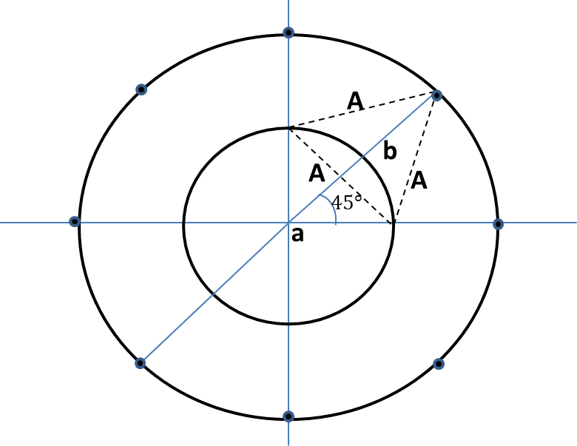

If the minimum distance between adjacent points is **A**, then the values of radii **a** and **b** are

1. **a** = **A**, **b** = **2A**
2. **a** = $\frac{A}{\sqrt{2}}$, **b** = **1.5A**
3. **a** = $\frac{A}{\sqrt{2}}$, **b** = **1.366A**
4. **a** = $\sqrt{2}$**A**, **b** = **2A**
5. Consider, a 8-ary PSK constellation given below. If the minimum distance is same for both, which one will be more preferable?

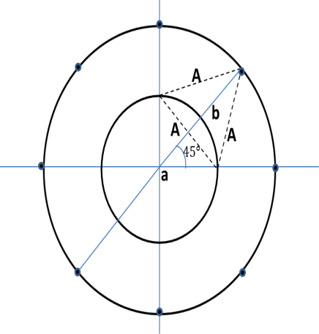 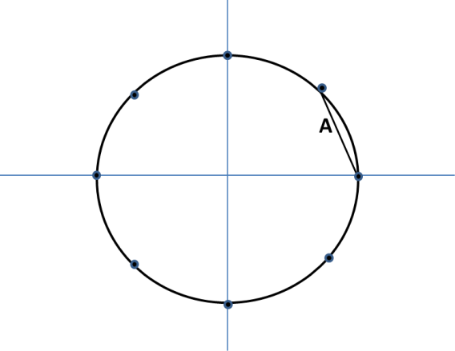

1. 8-PSK
2. 8-QAM
3. Both will be equally preferable.

Answers: 1.(a), 2.(d), 3.(b), 4.(c), 5.(c), 6.(b), 7.(d), 8.(b), 9.(c), 10.(b)